#
# 20210701
# https://tinkoff.slack.com/archives/G014XH9JP6C/p1625156344099000
#

Селин Павел 7:19 PM
Коллеги,
доделал pipeline unix-common на vm-gitlab01
Запускать можно тут https://vm-gitlab01.tcsbank.ru/Ansible/unix-common/pipelines/new
ansible-galaxy умеет скачивать роли из
- stash из проекта ANS_INT через Access key
- devplatform через сервисную учетку и утилиту dp
- vm-gitlab01 через Deploy Key
Переменные, которыми можно воздействовать на запуск ansible-playbook:
- INVENTORY - файл или хост, . По-умолчанию - inventories/epmty
- ansible_user - пользователь для подключения. По-умолчанию - unix-ansible. При необходимости можно смело менять на svc_unix_ansible, который из FreeIPA
- PLAYBOOK - плейбук из репозитория. По-умолчанию - useraddawx.yaml
Как безопасно передавать кастомные пароли (рута например) и приватные ключи пока не придумал. Сейчас это живёт в переменных CI/CD. Доступ к репе и её переменным ограничил.
Если есть идеи - заходите, обсудим.
Щупайте и фитбечте, пожалуйста =)
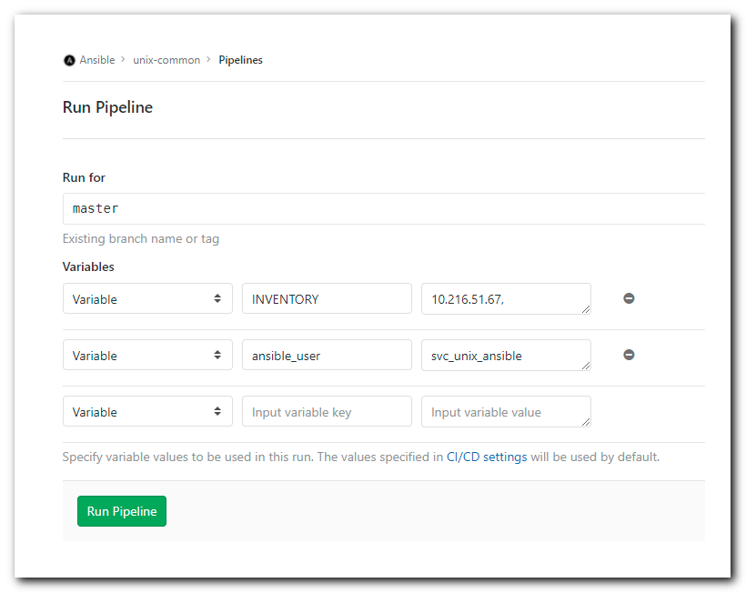

https://vm-gitlab01.tcsbank.ru/Ansible/unix-common
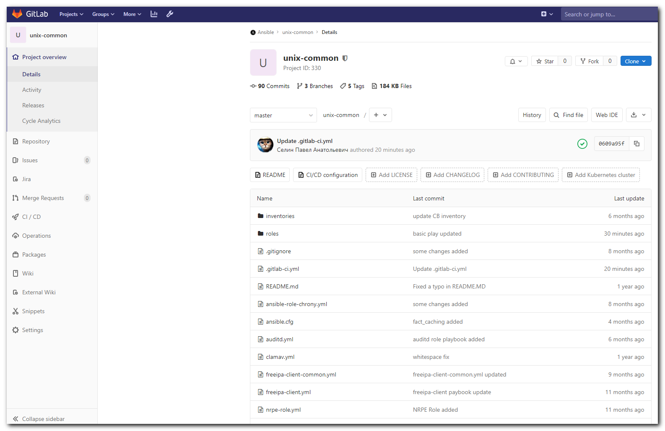

git@vm-gitlab01.tcsbank.ru:Ansible/unix-common.git

[s.belogrud@nb2339]# cd /drives/c/data/work/ansible/vm-gitlab01.tcsbank.ru/roles/ansible/
[s.belogrud@nb2339]# ll
total 2
drwxr-xr-x 1 s.belogr UsersGrp 0 Jun 25 13:15 nrpe-role
[s.belogrud@nb2339]# git clone -c http.sslVerify=false https://vm-gitlab01.tcsbank.ru/Ansible/unix-common.git
Клонирование в «unix-common»…
Username for 'https://vm-gitlab01.tcsbank.ru':
Password for 'https://s.belogrud@vm-gitlab01.tcsbank.ru':
remote: Enumerating objects: 335, done.
remote: Counting objects: 100% (335/335), done.
remote: Compressing objects: 100% (137/137), done.
remote: Total 335 (delta 174), reused 318 (delta 162), pack-reused 0
Получение объектов: 100% (335/335), 35.49 KiB | 318.00 KiB/s, готово.
Определение изменений: 100% (174/174), готово.
[s.belogrud@nb2339]#

[s.belogrud@nb2339]# ll
total 6
drwxr-xr-x 1 s.belogr UsersGrp 0 Jun 25 13:15 nrpe-role
drwxr-xr-x 1 s.belogr UsersGrp 0 Jun 30 17:43 unix-common
[s.belogrud@nb2339]# cd unix-common/
[s.belogrud@nb2339]# cat .git/config
[core]
repositoryformatversion = 0
filemode = true
bare = false
logallrefupdates = true
ignorecase = true
[http]
sslverify = false
[remote "origin"]
url = https://vm-gitlab01.tcsbank.ru/Ansible/unix-common.git
fetch = +refs/heads/*:refs/remotes/origin/*
[branch "master"]
remote = origin
merge = refs/heads/master
[s.belogrud@nb2339]# vim .git/config

[s.belogrud@nb2339]# cat .git/config
[core]
repositoryformatversion = 0
filemode = true
bare = false
logallrefupdates = true
ignorecase = true
[http]
sslverify = false
[remote "origin"]
url = ssh://git@vm-gitlab01.tcsbank.ru:22/Ansible/unix-common.git
url = https://vm-gitlab01.tcsbank.ru/Ansible/unix-common.git
fetch = +refs/heads/*:refs/remotes/origin/*
[branch "master"]
remote = origin
merge = refs/heads/master
[ssh]
identity = /home/mobaxterm/.ssh/id_rsa_s.belogrud

[s.belogrud@nb2339]#

[s.belogrud@nb2339]# git status
На ветке master
Ваша ветка обновлена в соответствии с «origin/master».

нечего коммитить, нет изменений в рабочем каталоге
[s.belogrud@nb2339]# git pull
stty: standard input: Inappropriate ioctl for device
Уже обновлено.
[s.belogrud@nb2339]#

# This is WSL.
[support@nb2339]# cd /mnt/c/data/work/ansible/vm-gitlab01.tcsbank.ru/roles/ansible/unix-common/
[support@nb2339]# git status
On branch master
Your branch is up to date with 'origin/master'.

nothing to commit, working tree clean
[support@nb2339]# git pull
Warning: Permanently added the RSA host key for IP address '10.216.48.48' to the list of known hosts.
Already up to date.
[support@nb2339]# git pull
Already up to date.
[support@nb2339]#

[s.belogrud@nb2339]# grep -ie "10.216.48.48" ~/.ssh/known_hosts
[s.belogrud@nb2339]#

# WSL.
#
#
# I was not liked installed things from one role to common for everything directory.
# I think I use virtual environment in this case.
#
[support@nb2339]# ansible-galaxy install -r roles/requirements.yml
[WARNING]: Ansible is being run in a world writable directory (/mnt/c/data/work/ansible/vm-gitlab01.tcsbank.ru/roles/ansible/unix-
common), ignoring it as an ansible.cfg source. For more information see
https://docs.ansible.com/ansible/devel/reference_appendices/config.html#cfg-in-world-writable-dir
The authenticity of host '[gitlab.tcsbank.ru]:7999 ([10.219.86.36]:7999)' can't be established.
ECDSA key fingerprint is SHA256:sEVm8i7qaWYl3WX7epHI1EUKa7/j5XxES4+ZnFfYGm0.
Are you sure you want to continue connecting (yes/no/[fingerprint])? yes
- extracting freeipa-client to /home/support/.ansible/roles/freeipa-client
- freeipa-client (v1.0.19) was installed successfully
- dependency ansible-role-chrony already pending installation.
- extracting auditd to /home/support/.ansible/roles/auditd
- auditd (v2.0.14) was installed successfully
- extracting openscap to /home/support/.ansible/roles/openscap
- openscap (v1.0.4) was installed successfully
- extracting trendmicro to /home/support/.ansible/roles/trendmicro
- trendmicro (v1.0.0) was installed successfully
- extracting clamav to /home/support/.ansible/roles/clamav
- clamav (v1.0.9) was installed successfully
- extracting ansible-role-chrony to /home/support/.ansible/roles/ansible-role-chrony
- ansible-role-chrony (v1.0.0) was installed successfully
- extracting commvault-agent to /home/support/.ansible/roles/commvault-agent
- commvault-agent (912a22a510bc52552c5ed71ec9c672ca53f225ba) was installed successfully
- extracting nrpe-role to /home/support/.ansible/roles/nrpe-role
- nrpe-role (v1.0.2) was installed successfully
- extracting repositories to /home/support/.ansible/roles/repositories
- repositories (v1.0.4) was installed successfully
- extracting docker to /home/support/.ansible/roles/docker
- docker (v1.4.0) was installed successfully
- extracting _metarole-prometheus-exporter-1.2.0 to /home/support/.ansible/roles/_metarole-prometheus-exporter-1.2.0
- _metarole-prometheus-exporter-1.2.0 (v1.2.0) was installed successfully
- extracting prometheus-node-exporter to /home/support/.ansible/roles/prometheus-node-exporter
- prometheus-node-exporter (v3.1.0) was installed successfully
- dependency _metarole-prometheus-exporter-1.2.0 is already installed, skipping.
[support@nb2339]#

[support@nb2339]# ls /home/support/.ansible/roles/
_metarole-prometheus-exporter-1.2.0 auditd commvault-agent freeipa-client openscap repositories
ansible-role-chrony clamav docker nrpe-role prometheus-node-exporter trendmicro
[support@nb2339]#

#
# I found several pythons and its links.
#
[support@nb2339]# python3
python3 python3-config python3.8 python3.8-config python3.exe
[support@nb2339]# which python3.exe
/mnt/c/Users/s.belogrud/AppData/Local/Microsoft/WindowsApps/python3.exe
[support@nb2339]# which python3.8
/usr/bin/python3.8
[support@nb2339]#

[support@nb2339]# ls -Alh /usr/bin/python*
-rwxr-xr-x 1 root root 2.5K Apr 14 2020 /usr/bin/python-argcomplete-check-easy-install-script3
-rwxr-xr-x 1 root root 314 Apr 14 2020 /usr/bin/python-argcomplete-tcsh3
lrwxrwxrwx 1 root root 9 Mar 13 2020 /usr/bin/python3 -> python3.8
lrwxrwxrwx 1 root root 16 Mar 13 2020 /usr/bin/python3-config -> python3.8-config
-rwxr-xr-x 1 root root 5.3M May 27 16:30 /usr/bin/python3.8
lrwxrwxrwx 1 root root 33 May 27 16:30 /usr/bin/python3.8-config -> x86_64-linux-gnu-python3.8-config
[support@nb2339]# ls -Alh /mnt/c/Users/s.belogrud/AppData/Local/Microsoft/WindowsApps/python3.exe
-r-xr-xr-x 1 support support 0 Mar 26 14:31 /mnt/c/Users/s.belogrud/AppData/Local/Microsoft/WindowsApps/python3.exe
[support@nb2339]#

[support@nb2339]# pwd
/mnt/c/data/work/ansible/vm-gitlab01.tcsbank.ru/roles/ansible/unix-common
[support@nb2339]#

[support@nb2339]# python3 -m venv env
The virtual environment was not created successfully because ensurepip is not
available. On Debian/Ubuntu systems, you need to install the python3-venv
package using the following command.

apt-get install python3-venv

You may need to use sudo with that command. After installing the python3-venv
package, recreate your virtual environment.

Failing command: ['/mnt/c/data/work/ansible/vm-gitlab01.tcsbank.ru/roles/ansible/unix-common/env/bin/python3', '-Im', 'ensurepip', '--upgrade', '--default-pip']

[support@nb2339]#

[support@nb2339]# sudo apt install python3-venv
[sudo] password for support:
Reading package lists... Done
Building dependency tree
Reading state information... Done
The following additional packages will be installed:
python3.8-venv
The following NEW packages will be installed:
python3-venv python3.8-venv
0 upgraded, 2 newly installed, 0 to remove and 0 not upgraded.
Need to get 6672 B of archives.
After this operation, 38.9 kB of additional disk space will be used.
Do you want to continue? [Y/n] Y
Get:1 http://archive.ubuntu.com/ubuntu focal-updates/universe amd64 python3.8-venv amd64 3.8.5-1~20.04.3 [5444 B]
Get:2 http://archive.ubuntu.com/ubuntu focal/universe amd64 python3-venv amd64 3.8.2-0ubuntu2 [1228 B]
Fetched 6672 B in 0s (16.6 kB/s)
Selecting previously unselected package python3.8-venv.
(Reading database ... 47909 files and directories currently installed.)
Preparing to unpack .../python3.8-venv_3.8.5-1~20.04.3_amd64.deb ...
Unpacking python3.8-venv (3.8.5-1~20.04.3) ...
Selecting previously unselected package python3-venv.
Preparing to unpack .../python3-venv_3.8.2-0ubuntu2_amd64.deb ...
Unpacking python3-venv (3.8.2-0ubuntu2) ...
Setting up python3.8-venv (3.8.5-1~20.04.3) ...
Setting up python3-venv (3.8.2-0ubuntu2) ...
Processing triggers for man-db (2.9.1-1) ...
[support@nb2339]#

[support@nb2339]# python3 -m venv env
[support@nb2339]#

[support@nb2339]# ls -Alhd env/
drwxrwxrwx 1 support support 512 Jul 1 13:55 env/
[support@nb2339]#

[support@nb2339]# source env/bin/activate
(env) [support@nb2339]#

(env) [support@nb2339]# ansible-galaxy install -r roles/requirements.yml
Traceback (most recent call last):
File "/usr/bin/ansible-galaxy", line 34, in <module>
from ansible import context
ModuleNotFoundError: No module named 'ansible'
(env) [support@nb2339]#

(env) [support@nb2339]# pip install -Ur requirements.txt
Collecting ansible<=2.9.14,>=2.9
Downloading ansible-2.9.14.tar.gz (14.3 MB)
|████████████████████████████████| 14.3 MB 390 kB/s

Collecting molecule==2.22
Downloading molecule-2.22-py2.py3-none-any.whl (469 kB)
|████████████████████████████████| 469 kB 5.8 MB/s
Collecting dnspython
Downloading dnspython-2.1.0-py3-none-any.whl (241 kB)
|████████████████████████████████| 241 kB 3.2 MB/s
Collecting testinfra
Downloading testinfra-6.0.0-py3-none-any.whl (2.1 kB)
Collecting docker
Downloading docker-5.0.0-py2.py3-none-any.whl (146 kB)
|████████████████████████████████| 146 kB 6.9 MB/s
Collecting PyYAML
Downloading PyYAML-5.4.1-cp38-cp38-manylinux1_x86_64.whl (662 kB)
|████████████████████████████████| 662 kB 6.0 MB/s
Collecting cryptography
Downloading cryptography-3.4.7-cp36-abi3-manylinux2014_x86_64.whl (3.2 MB)
|████████████████████████████████| 3.2 MB 9.4 MB/s
Collecting jinja2
Downloading Jinja2-3.0.1-py3-none-any.whl (133 kB)
|████████████████████████████████| 133 kB 4.4 MB/s
Collecting tree-format>=0.1.2
Downloading tree-format-0.1.2.tar.gz (4.0 kB)
Collecting pexpect<5,>=4.6.0
Downloading pexpect-4.8.0-py2.py3-none-any.whl (59 kB)
|████████████████████████████████| 59 kB 1.4 MB/s
Collecting six>=1.11.0
Downloading six-1.16.0-py2.py3-none-any.whl (11 kB)
Collecting python-gilt<2,>=1.2.1
Downloading python_gilt-1.2.3-py2.py3-none-any.whl (22 kB)
Collecting colorama>=0.3.9
Downloading colorama-0.4.4-py2.py3-none-any.whl (16 kB)
Collecting psutil<6,>=5.4.6; sys_platform != "win32" and sys_platform != "cygwin"
Downloading psutil-5.8.0-cp38-cp38-manylinux2010_x86_64.whl (296 kB)
|████████████████████████████████| 296 kB 7.9 MB/s
Collecting click-completion>=0.3.1
Downloading click-completion-0.5.2.tar.gz (10 kB)
Collecting pre-commit<2,>=1.17.0
Downloading pre_commit-1.21.0-py2.py3-none-any.whl (166 kB)
|████████████████████████████████| 166 kB 6.4 MB/s
Collecting paramiko<3,>=2.5.0
Downloading paramiko-2.7.2-py2.py3-none-any.whl (206 kB)
|████████████████████████████████| 206 kB 3.2 MB/s
Collecting cookiecutter>=1.6.0
Downloading cookiecutter-1.7.3-py2.py3-none-any.whl (34 kB)
Collecting click>=6.7
Downloading click-8.0.1-py3-none-any.whl (97 kB)
|████████████████████████████████| 97 kB 2.2 MB/s
Collecting anyconfig==0.9.7
Downloading anyconfig-0.9.7.tar.gz (97 kB)
|████████████████████████████████| 97 kB 2.3 MB/s
Collecting tabulate>=0.8.3
Downloading tabulate-0.8.9-py3-none-any.whl (25 kB)
Collecting cerberus>=1.3.1
Downloading Cerberus-1.3.4.tar.gz (63 kB)
|████████████████████████████████| 63 kB 948 kB/s
Installing build dependencies ... done
Getting requirements to build wheel ... done
Preparing wheel metadata ... done
Collecting flake8>=3.6.0
Downloading flake8-3.9.2-py2.py3-none-any.whl (73 kB)
|████████████████████████████████| 73 kB 253 kB/s
Collecting ansible-lint<5,>=4.0.2
Downloading ansible_lint-4.3.7-py2.py3-none-any.whl (79 kB)
|████████████████████████████████| 79 kB 2.2 MB/s
Collecting yamllint<2,>=1.15.0
Downloading yamllint-1.26.1.tar.gz (126 kB)
|████████████████████████████████| 126 kB 4.3 MB/s
Collecting sh>=1.12.14
Downloading sh-1.14.2-py2.py3-none-any.whl (40 kB)
|████████████████████████████████| 40 kB 2.2 MB/s
Collecting pytest-testinfra
Downloading pytest_testinfra-6.4.0-py3-none-any.whl (71 kB)
|████████████████████████████████| 71 kB 56 kB/s
Collecting requests!=2.18.0,>=2.14.2
Downloading requests-2.25.1-py2.py3-none-any.whl (61 kB)
|████████████████████████████████| 61 kB 1.9 MB/s
Collecting websocket-client>=0.32.0
Downloading websocket_client-1.1.0-py2.py3-none-any.whl (68 kB)
|████████████████████████████████| 68 kB 2.1 MB/s
Collecting cffi>=1.12
Downloading cffi-1.14.5-cp38-cp38-manylinux1_x86_64.whl (411 kB)
|████████████████████████████████| 411 kB 3.4 MB/s
Collecting MarkupSafe>=2.0
Downloading MarkupSafe-2.0.1-cp38-cp38-manylinux2010_x86_64.whl (30 kB)
Collecting ptyprocess>=0.5
Downloading ptyprocess-0.7.0-py2.py3-none-any.whl (13 kB)
Collecting fasteners
Downloading fasteners-0.16.3-py2.py3-none-any.whl (28 kB)
Collecting shellingham
Downloading shellingham-1.4.0-py2.py3-none-any.whl (9.4 kB)
Collecting toml
Downloading toml-0.10.2-py2.py3-none-any.whl (16 kB)
Collecting identify>=1.0.0
Downloading identify-2.2.10-py2.py3-none-any.whl (98 kB)
|████████████████████████████████| 98 kB 2.9 MB/s
Collecting cfgv>=2.0.0
Downloading cfgv-3.3.0-py2.py3-none-any.whl (7.3 kB)
Collecting nodeenv>=0.11.1
Downloading nodeenv-1.6.0-py2.py3-none-any.whl (21 kB)
Collecting virtualenv>=15.2
Downloading virtualenv-20.4.7-py2.py3-none-any.whl (7.2 MB)
|████████████████████████████████| 7.2 MB 6.4 MB/s
Collecting aspy.yaml
Downloading aspy.yaml-1.3.0-py2.py3-none-any.whl (3.5 kB)
Collecting pynacl>=1.0.1
Downloading PyNaCl-1.4.0-cp35-abi3-manylinux1_x86_64.whl (961 kB)
|████████████████████████████████| 961 kB 5.1 MB/s
Collecting bcrypt>=3.1.3
Downloading bcrypt-3.2.0-cp36-abi3-manylinux2010_x86_64.whl (63 kB)
|████████████████████████████████| 63 kB 73 kB/s
Collecting python-slugify>=4.0.0
Downloading python_slugify-5.0.2-py2.py3-none-any.whl (6.7 kB)
Collecting binaryornot>=0.4.4
Downloading binaryornot-0.4.4-py2.py3-none-any.whl (9.0 kB)
Collecting poyo>=0.5.0
Downloading poyo-0.5.0-py2.py3-none-any.whl (10 kB)
Collecting jinja2-time>=0.2.0
Downloading jinja2_time-0.2.0-py2.py3-none-any.whl (6.4 kB)
Requirement already satisfied, skipping upgrade: setuptools in ./env/lib/python3.8/site-packages (from cerberus>=1.3.1->molecule==2.22->-r requirements.txt (line 2)) (44.0.0)
Collecting mccabe<0.7.0,>=0.6.0
Downloading mccabe-0.6.1-py2.py3-none-any.whl (8.6 kB)
Collecting pyflakes<2.4.0,>=2.3.0
Downloading pyflakes-2.3.1-py2.py3-none-any.whl (68 kB)
|████████████████████████████████| 68 kB 1.7 MB/s
Collecting pycodestyle<2.8.0,>=2.7.0
Downloading pycodestyle-2.7.0-py2.py3-none-any.whl (41 kB)
|████████████████████████████████| 41 kB 101 kB/s
Collecting rich
Downloading rich-10.4.0-py3-none-any.whl (206 kB)
|████████████████████████████████| 206 kB 21.2 MB/s
Collecting ruamel.yaml<1,>=0.15.37; python_version >= "3.7"
Downloading ruamel.yaml-0.17.10-py3-none-any.whl (108 kB)
|████████████████████████████████| 108 kB 57 kB/s
Collecting pathspec>=0.5.3
Downloading pathspec-0.8.1-py2.py3-none-any.whl (28 kB)
Collecting pytest!=3.0.2
Downloading pytest-6.2.4-py3-none-any.whl (280 kB)
|████████████████████████████████| 280 kB 253 kB/s
Collecting idna<3,>=2.5
Downloading idna-2.10-py2.py3-none-any.whl (58 kB)
|████████████████████████████████| 58 kB 600 kB/s
Collecting certifi>=2017.4.17
Downloading certifi-2021.5.30-py2.py3-none-any.whl (145 kB)
|████████████████████████████████| 145 kB 829 kB/s
Collecting chardet<5,>=3.0.2
Downloading chardet-4.0.0-py2.py3-none-any.whl (178 kB)
|████████████████████████████████| 178 kB 993 kB/s
Collecting urllib3<1.27,>=1.21.1
Downloading urllib3-1.26.6-py2.py3-none-any.whl (138 kB)
|████████████████████████████████| 138 kB 1.3 MB/s
Collecting pycparser
Downloading pycparser-2.20-py2.py3-none-any.whl (112 kB)
|████████████████████████████████| 112 kB 1.5 MB/s
Collecting filelock<4,>=3.0.0
Downloading filelock-3.0.12-py3-none-any.whl (7.6 kB)
Collecting appdirs<2,>=1.4.3
Downloading appdirs-1.4.4-py2.py3-none-any.whl (9.6 kB)
Collecting distlib<1,>=0.3.1
Downloading distlib-0.3.2-py2.py3-none-any.whl (338 kB)
|████████████████████████████████| 338 kB 1.6 MB/s
Collecting text-unidecode>=1.3
Downloading text_unidecode-1.3-py2.py3-none-any.whl (78 kB)
|████████████████████████████████| 78 kB 1.7 MB/s
Collecting arrow
Downloading arrow-1.1.1-py3-none-any.whl (60 kB)
|████████████████████████████████| 60 kB 2.0 MB/s
Collecting commonmark<0.10.0,>=0.9.0
Downloading commonmark-0.9.1-py2.py3-none-any.whl (51 kB)
|████████████████████████████████| 51 kB 1.8 MB/s
Collecting pygments<3.0.0,>=2.6.0
Downloading Pygments-2.9.0-py3-none-any.whl (1.0 MB)
|████████████████████████████████| 1.0 MB 2.2 MB/s
Collecting ruamel.yaml.clib>=0.1.2; platform_python_implementation == "CPython" and python_version < "3.10"
Downloading ruamel.yaml.clib-0.2.4-cp38-cp38-manylinux1_x86_64.whl (570 kB)
|████████████████████████████████| 570 kB 4.5 MB/s
Collecting packaging
Downloading packaging-20.9-py2.py3-none-any.whl (40 kB)
|████████████████████████████████| 40 kB 1.7 MB/s
Collecting iniconfig
Downloading iniconfig-1.1.1-py2.py3-none-any.whl (5.0 kB)
Collecting py>=1.8.2
Downloading py-1.10.0-py2.py3-none-any.whl (97 kB)
|████████████████████████████████| 97 kB 2.4 MB/s
Collecting attrs>=19.2.0
Downloading attrs-21.2.0-py2.py3-none-any.whl (53 kB)
|████████████████████████████████| 53 kB 407 kB/s
Collecting pluggy<1.0.0a1,>=0.12
Downloading pluggy-0.13.1-py2.py3-none-any.whl (18 kB)
Collecting python-dateutil>=2.7.0
Downloading python_dateutil-2.8.1-py2.py3-none-any.whl (227 kB)
|████████████████████████████████| 227 kB 5.4 MB/s
Collecting pyparsing>=2.0.2
Downloading pyparsing-2.4.7-py2.py3-none-any.whl (67 kB)
|████████████████████████████████| 67 kB 1.9 MB/s
Building wheels for collected packages: ansible, tree-format, click-completion, anyconfig, cerberus, yamllint
Building wheel for ansible (setup.py) ... error
ERROR: Command errored out with exit status 1:
command: /mnt/c/data/work/ansible/vm-gitlab01.tcsbank.ru/roles/ansible/unix-common/env/bin/python3 -u -c 'import sys, setuptools, tokenize; sys.argv[0] = '"'"'/tmp/pip-install-9vhfuud5/ansible/setup.py'"'"'; __file__='"'"'/tmp/pip-install-9vhfuud5/ansible/setup.py'"'"';f=getattr(tokenize, '"'"'open'"'"', open)(__file__);code=f.read().replace('"'"'\r\n'"'"', '"'"'\n'"'"');f.close();exec(compile(code, __file__, '"'"'exec'"'"'))' bdist_wheel -d /tmp/pip-wheel-yfzkqn2h
cwd: /tmp/pip-install-9vhfuud5/ansible/
Complete output (6 lines):
usage: setup.py [global_opts] cmd1 [cmd1_opts] [cmd2 [cmd2_opts] ...]
or: setup.py --help [cmd1 cmd2 ...]
or: setup.py --help-commands
or: setup.py cmd --help

error: invalid command 'bdist_wheel'
----------------------------------------
ERROR: Failed building wheel for ansible
Running setup.py clean for ansible
Building wheel for tree-format (setup.py) ... error
ERROR: Command errored out with exit status 1:
command: /mnt/c/data/work/ansible/vm-gitlab01.tcsbank.ru/roles/ansible/unix-common/env/bin/python3 -u -c 'import sys, setuptools, tokenize; sys.argv[0] = '"'"'/tmp/pip-install-9vhfuud5/tree-format/setup.py'"'"'; __file__='"'"'/tmp/pip-install-9vhfuud5/tree-format/setup.py'"'"';f=getattr(tokenize, '"'"'open'"'"', open)(__file__);code=f.read().replace('"'"'\r\n'"'"', '"'"'\n'"'"');f.close();exec(compile(code, __file__, '"'"'exec'"'"'))' bdist_wheel -d /tmp/pip-wheel-_bevd4by
cwd: /tmp/pip-install-9vhfuud5/tree-format/
Complete output (6 lines):
usage: setup.py [global_opts] cmd1 [cmd1_opts] [cmd2 [cmd2_opts] ...]
or: setup.py --help [cmd1 cmd2 ...]
or: setup.py --help-commands
or: setup.py cmd --help

error: invalid command 'bdist_wheel'
----------------------------------------
ERROR: Failed building wheel for tree-format
Running setup.py clean for tree-format
Building wheel for click-completion (setup.py) ... error
ERROR: Command errored out with exit status 1:
command: /mnt/c/data/work/ansible/vm-gitlab01.tcsbank.ru/roles/ansible/unix-common/env/bin/python3 -u -c 'import sys, setuptools, tokenize; sys.argv[0] = '"'"'/tmp/pip-install-9vhfuud5/click-completion/setup.py'"'"'; __file__='"'"'/tmp/pip-install-9vhfuud5/click-completion/setup.py'"'"';f=getattr(tokenize, '"'"'open'"'"', open)(__file__);code=f.read().replace('"'"'\r\n'"'"', '"'"'\n'"'"');f.close();exec(compile(code, __file__, '"'"'exec'"'"'))' bdist_wheel -d /tmp/pip-wheel-sce5jjvm
cwd: /tmp/pip-install-9vhfuud5/click-completion/
Complete output (6 lines):
usage: setup.py [global_opts] cmd1 [cmd1_opts] [cmd2 [cmd2_opts] ...]
or: setup.py --help [cmd1 cmd2 ...]
or: setup.py --help-commands
or: setup.py cmd --help

error: invalid command 'bdist_wheel'
----------------------------------------
ERROR: Failed building wheel for click-completion
Running setup.py clean for click-completion
Building wheel for anyconfig (setup.py) ... error
ERROR: Command errored out with exit status 1:
command: /mnt/c/data/work/ansible/vm-gitlab01.tcsbank.ru/roles/ansible/unix-common/env/bin/python3 -u -c 'import sys, setuptools, tokenize; sys.argv[0] = '"'"'/tmp/pip-install-9vhfuud5/anyconfig/setup.py'"'"'; __file__='"'"'/tmp/pip-install-9vhfuud5/anyconfig/setup.py'"'"';f=getattr(tokenize, '"'"'open'"'"', open)(__file__);code=f.read().replace('"'"'\r\n'"'"', '"'"'\n'"'"');f.close();exec(compile(code, __file__, '"'"'exec'"'"'))' bdist_wheel -d /tmp/pip-wheel-j1uy560m
cwd: /tmp/pip-install-9vhfuud5/anyconfig/
Complete output (6 lines):
usage: setup.py [global_opts] cmd1 [cmd1_opts] [cmd2 [cmd2_opts] ...]
or: setup.py --help [cmd1 cmd2 ...]
or: setup.py --help-commands
or: setup.py cmd --help

error: invalid command 'bdist_wheel'
----------------------------------------
ERROR: Failed building wheel for anyconfig
Running setup.py clean for anyconfig
Building wheel for cerberus (PEP 517) ... done
Created wheel for cerberus: filename=Cerberus-1.3.4-py3-none-any.whl size=58196 sha256=6444f0915c8c7824cb2fcd96d2f483d44984308d55d20cb1abf2841e812e8795
Stored in directory: /home/support/.cache/pip/wheels/92/1e/40/307520b5eb38ceae17d32d7d7920e3e5eee6f4cd78cfd75ac7
Building wheel for yamllint (setup.py) ... error
ERROR: Command errored out with exit status 1:
command: /mnt/c/data/work/ansible/vm-gitlab01.tcsbank.ru/roles/ansible/unix-common/env/bin/python3 -u -c 'import sys, setuptools, tokenize; sys.argv[0] = '"'"'/tmp/pip-install-9vhfuud5/yamllint/setup.py'"'"'; __file__='"'"'/tmp/pip-install-9vhfuud5/yamllint/setup.py'"'"';f=getattr(tokenize, '"'"'open'"'"', open)(__file__);code=f.read().replace('"'"'\r\n'"'"', '"'"'\n'"'"');f.close();exec(compile(code, __file__, '"'"'exec'"'"'))' bdist_wheel -d /tmp/pip-wheel-16dbbowi
cwd: /tmp/pip-install-9vhfuud5/yamllint/
Complete output (6 lines):
usage: setup.py [global_opts] cmd1 [cmd1_opts] [cmd2 [cmd2_opts] ...]
or: setup.py --help [cmd1 cmd2 ...]
or: setup.py --help-commands
or: setup.py cmd --help

error: invalid command 'bdist_wheel'
----------------------------------------
ERROR: Failed building wheel for yamllint
Running setup.py clean for yamllint
Successfully built cerberus
Failed to build ansible tree-format click-completion anyconfig yamllint
ERROR: molecule 2.22 has requirement testinfra<4,>=3.0.6, but you'll have testinfra 6.0.0 which is incompatible.
Installing collected packages: PyYAML, pycparser, cffi, cryptography, MarkupSafe, jinja2, ansible, tree-format, ptyprocess, pexpect, six, pyparsing, packaging, iniconfig, toml, py, attrs, pluggy, pytest, pytest-testinfra, testinfra, colorama, sh, click, fasteners, python-gilt, psutil, shellingham, click-completion, identify, cfgv, nodeenv, filelock, appdirs, distlib, virtualenv, aspy.yaml, pre-commit, pynacl, bcrypt, paramiko, text-unidecode, python-slugify, chardet, binaryornot, poyo, idna, certifi, urllib3, requests, python-dateutil, arrow, jinja2-time, cookiecutter, anyconfig, tabulate, cerberus, mccabe, pyflakes, pycodestyle, flake8, commonmark, pygments, rich, ruamel.yaml.clib, ruamel.yaml, ansible-lint, pathspec, yamllint, molecule, dnspython, websocket-client, docker
Running setup.py install for ansible ... \

Running setup.py install for ansible ... done
Running setup.py install for tree-format ... done
Running setup.py install for click-completion ... done
Running setup.py install for anyconfig ... done
Running setup.py install for yamllint ... done
Successfully installed MarkupSafe-2.0.1 PyYAML-5.4.1 ansible-2.9.14 ansible-lint-4.3.7 anyconfig-0.9.7 appdirs-1.4.4 arrow-1.1.1 aspy.yaml-1.3.0 attrs-21.2.0 bcrypt-3.2.0 binaryornot-0.4.4 cerberus-1.3.4 certifi-2021.5.30 cffi-1.14.5 cfgv-3.3.0 chardet-4.0.0 click-8.0.1 click-completion-0.5.2 colorama-0.4.4 commonmark-0.9.1 cookiecutter-1.7.3 cryptography-3.4.7 distlib-0.3.2 dnspython-2.1.0 docker-5.0.0 fasteners-0.16.3 filelock-3.0.12 flake8-3.9.2 identify-2.2.10 idna-2.10 iniconfig-1.1.1 jinja2-3.0.1 jinja2-time-0.2.0 mccabe-0.6.1 molecule-2.22 nodeenv-1.6.0 packaging-20.9 paramiko-2.7.2 pathspec-0.8.1 pexpect-4.8.0 pluggy-0.13.1 poyo-0.5.0 pre-commit-1.21.0 psutil-5.8.0 ptyprocess-0.7.0 py-1.10.0 pycodestyle-2.7.0 pycparser-2.20 pyflakes-2.3.1 pygments-2.9.0 pynacl-1.4.0 pyparsing-2.4.7 pytest-6.2.4 pytest-testinfra-6.4.0 python-dateutil-2.8.1 python-gilt-1.2.3 python-slugify-5.0.2 requests-2.25.1 rich-10.4.0 ruamel.yaml-0.17.10 ruamel.yaml.clib-0.2.4 sh-1.14.2 shellingham-1.4.0 six-1.16.0 tabulate-0.8.9 testinfra-6.0.0 text-unidecode-1.3 toml-0.10.2 tree-format-0.1.2 urllib3-1.26.6 virtualenv-20.4.7 websocket-client-1.1.0 yamllint-1.26.1
(env) [support@nb2339]#

(env) [support@nb2339]# du -sh env/
192M env/
(env) [support@nb2339]#

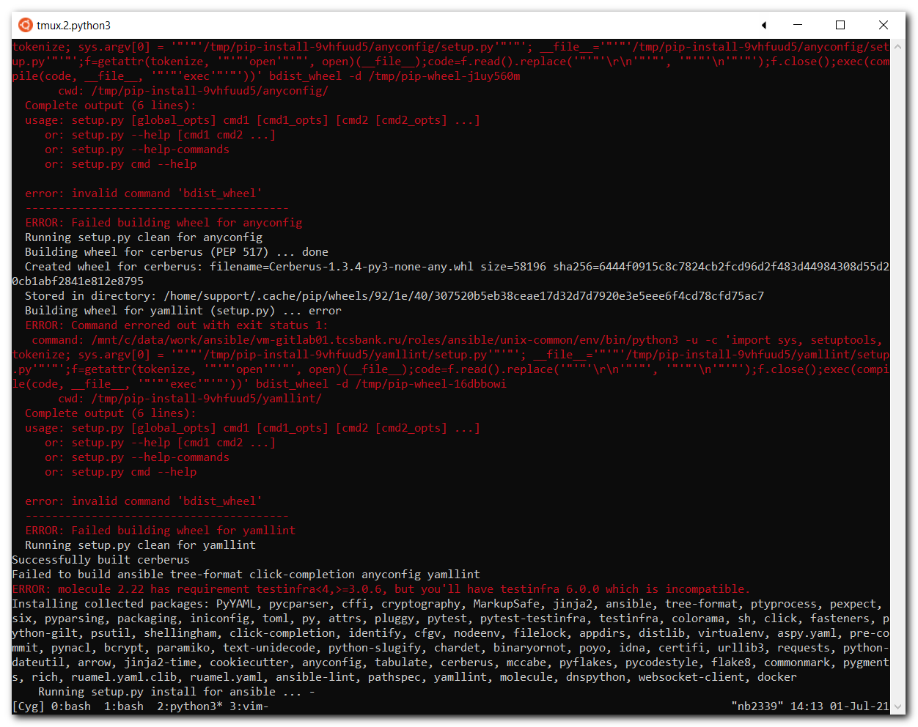
#
# Well, this command did nothing, because it was already did.
# I thought, that under env it could be differ.
# https://docs.ansible.com/ansible/latest/reference_appendices/config.html#default-roles-path
# "Storing and finding roles" https://docs.ansible.com/ansible/latest/user_guide/playbooks_reuse_roles.html
# "Config paths" https://docs.ansible.com/ansible/latest/user_guide/playbook_pathing.html
#
(env) [support@nb2339]# ansible-galaxy install -r roles/requirements.yml
[WARNING]: Ansible is being run in a world writable directory (/mnt/c/data/work/ansible/vm-gitlab01.tcsbank.ru/roles/ansible/unix-
common), ignoring it as an ansible.cfg source. For more information see
https://docs.ansible.com/ansible/devel/reference_appendices/config.html#cfg-in-world-writable-dir
- freeipa-client (v1.0.19) is already installed, skipping.
- auditd (v2.0.14) is already installed, skipping.
- openscap (v1.0.4) is already installed, skipping.
- trendmicro (v1.0.0) is already installed, skipping.
- clamav (v1.0.9) is already installed, skipping.
- ansible-role-chrony (v1.0.0) is already installed, skipping.
- commvault-agent (912a22a510bc52552c5ed71ec9c672ca53f225ba) is already installed, skipping.
- nrpe-role (v1.0.2) is already installed, skipping.
- repositories (v1.0.4) is already installed, skipping.
- docker (v1.4.0) is already installed, skipping.
- _metarole-prometheus-exporter-1.2.0 (v1.2.0) is already installed, skipping.
- prometheus-node-exporter (v3.1.0) is already installed, skipping.
(env) [support@nb2339]#

# Here I tested, that role from requirements.yml was extracted exactly to ./ansible/roles.
(env) [support@nb2339]# ls /home/support/.ansible/roles/
_metarole-prometheus-exporter-1.2.0 auditd commvault-agent freeipa-client openscap repositories
ansible-role-chrony clamav docker nrpe-role prometheus-node-exporter trendmicro
(env) [support@nb2339]#
(env) [support@nb2339]# ls roles
requirements.yml
(env) [support@nb2339]# rm -rf /home/support/.ansible/roles/repositories/
(env) [support@nb2339]# ansible-galaxy install -r roles/requirements.yml
[WARNING]: Ansible is being run in a world writable directory (/mnt/c/data/work/ansible/vm-gitlab01.tcsbank.ru/roles/ansible/unix-
common), ignoring it as an ansible.cfg source. For more information see
https://docs.ansible.com/ansible/devel/reference_appendices/config.html#cfg-in-world-writable-dir
- freeipa-client (v1.0.19) is already installed, skipping.
- auditd (v2.0.14) is already installed, skipping.
- openscap (v1.0.4) is already installed, skipping.
- trendmicro (v1.0.0) is already installed, skipping.
- clamav (v1.0.9) is already installed, skipping.
- ansible-role-chrony (v1.0.0) is already installed, skipping.
- commvault-agent (912a22a510bc52552c5ed71ec9c672ca53f225ba) is already installed, skipping.
- nrpe-role (v1.0.2) is already installed, skipping.
- extracting repositories to /home/support/.ansible/roles/repositories
- repositories (v1.0.4) was installed successfully
- docker (v1.4.0) is already installed, skipping.
- _metarole-prometheus-exporter-1.2.0 (v1.2.0) is already installed, skipping.
- prometheus-node-exporter (v3.1.0) is already installed, skipping.
(env) [support@nb2339]#

(env) [support@nb2339]# ls -Alh /home/support/.ansible/roles/
total 0
drwxr-xr-x 1 support support 512 Jul 1 13:33 _metarole-prometheus-exporter-1.2.0
drwxr-xr-x 1 support support 512 Jul 1 13:32 ansible-role-chrony
drwxr-xr-x 1 support support 512 Jul 1 13:32 auditd
drwxr-xr-x 1 support support 512 Jul 1 13:32 clamav
drwxr-xr-x 1 support support 512 Jul 1 13:33 commvault-agent
drwxr-xr-x 1 support support 512 Jul 1 13:33 docker
drwxr-xr-x 1 support support 512 Jul 1 13:32 freeipa-client
drwxr-xr-x 1 support support 512 Jul 1 13:33 nrpe-role
drwxr-xr-x 1 support support 512 Jul 1 13:32 openscap
drwxr-xr-x 1 support support 512 Jul 1 13:33 prometheus-node-exporter
drwxr-xr-x 1 support support 512 Jul 1 14:27 repositories
drwxr-xr-x 1 support support 512 Jul 1 13:32 trendmicro
(env) [support@nb2339]#

(env) [support@nb2339]# rm -rf /home/support/.ansible/roles/*
(env) [support@nb2339]# ls -Alh /home/support/.ansible/roles/
total 0
(env) [support@nb2339]#

(env) [support@nb2339]# export ANSIBLE_CONFIG=ansible.cfg ; ansible-galaxy install -r roles/requirements.yml -p ./roles/
- extracting freeipa-client to /mnt/c/data/work/ansible/vm-gitlab01.tcsbank.ru/roles/ansible/unix-common/roles/freeipa-client
- freeipa-client (v1.0.19) was installed successfully
- dependency ansible-role-chrony already pending installation.
- extracting auditd to /mnt/c/data/work/ansible/vm-gitlab01.tcsbank.ru/roles/ansible/unix-common/roles/auditd
- auditd (v2.0.14) was installed successfully
- extracting openscap to /mnt/c/data/work/ansible/vm-gitlab01.tcsbank.ru/roles/ansible/unix-common/roles/openscap
- openscap (v1.0.4) was installed successfully
- extracting trendmicro to /mnt/c/data/work/ansible/vm-gitlab01.tcsbank.ru/roles/ansible/unix-common/roles/trendmicro
- trendmicro (v1.0.0) was installed successfully
- extracting clamav to /mnt/c/data/work/ansible/vm-gitlab01.tcsbank.ru/roles/ansible/unix-common/roles/clamav
- clamav (v1.0.9) was installed successfully
- extracting ansible-role-chrony to /mnt/c/data/work/ansible/vm-gitlab01.tcsbank.ru/roles/ansible/unix-common/roles/ansible-role-chrony
- ansible-role-chrony (v1.0.0) was installed successfully
- extracting commvault-agent to /mnt/c/data/work/ansible/vm-gitlab01.tcsbank.ru/roles/ansible/unix-common/roles/commvault-agent
- commvault-agent (912a22a510bc52552c5ed71ec9c672ca53f225ba) was installed successfully
- extracting nrpe-role to /mnt/c/data/work/ansible/vm-gitlab01.tcsbank.ru/roles/ansible/unix-common/roles/nrpe-role
- nrpe-role (v1.0.2) was installed successfully
- extracting repositories to /mnt/c/data/work/ansible/vm-gitlab01.tcsbank.ru/roles/ansible/unix-common/roles/repositories
- repositories (v1.0.4) was installed successfully
- extracting docker to /mnt/c/data/work/ansible/vm-gitlab01.tcsbank.ru/roles/ansible/unix-common/roles/docker
- docker (v1.4.0) was installed successfully
- extracting _metarole-prometheus-exporter-1.2.0 to /mnt/c/data/work/ansible/vm-gitlab01.tcsbank.ru/roles/ansible/unix-common/roles/_metarole-prometheus-exporter-1.2.0
- _metarole-prometheus-exporter-1.2.0 (v1.2.0) was installed successfully
- extracting prometheus-node-exporter to /mnt/c/data/work/ansible/vm-gitlab01.tcsbank.ru/roles/ansible/unix-common/roles/prometheus-node-exporter
- prometheus-node-exporter (v3.1.0) was installed successfully
- dependency _metarole-prometheus-exporter-1.2.0 is already installed, skipping.
(env) [support@nb2339]#

# Here I deactivated environment. I wanted test how it works without any environments. Especially if environment had several errors during installation.
(env) [support@nb2339]# deactivate
[support@nb2339]#

#
# My changings.
#

C:\data\work\ansible\vm-gitlab01.tcsbank.ru\roles\ansible\unix-common\ansible.cfg

[defaults]
internal_poll_interval = 0.05
interpreter_python = auto_silent
callback_whitelist = profile_tasks
bin_ansible_callbacks = True
deprecation_warnings = False
host_key_checking = False
command_warnings = False
## roles_path = roles
roles_path = ansible/unix-common/roles
## retry_files_enabled = False
## retry_files_save_path = /var/run
retry_files_enabled = True
retry_files_save_path = ./retry
#vault_password_file = ~/.vault
timeout = 30
forks = 20
## fact_caching_connection = "mongodb://ds-ansible-cache01p.tcsbank.ru:27017,ds-ansible-cache02p.tcsbank.ru:27017,m1-ansible-cache01p.tcsbank.ru:27017/?replicaSet=ansible-cache"
## fact_caching=mongodb
## fact_caching_timeout=2678400
## fact_caching_prefix=ansible_facts_
#
# https://docs.ansible.com/ansible/2.4/intro_configuration.html#pipelining
pipelining = True

[privilege_escalation]
become=True
become_method=sudo
become_user=root
## become_ask_pass=True

# [connection]
# pipelining = true

[ssh_connection]
ssh_args = -C -o ControlMaster=auto -o ControlPersist=60s -o UserKnownHostsFile=/dev/null -o StrictHostKeyChecking=no -o PreferredAuthentications=publickey,password

# Directory ./retry creates in this repository. I don't know why so...
#

C:\data\work\ansible\vm-gitlab01.tcsbank.ru\roles\ansible\unix-common\useraddawx.yaml

#!/usr/bin/env ansible-playbook
---
# - hosts: all
- hosts: unix_common
become: true
serial: "{{ srl | default(20) }}"
vars:
sudo_gr: "{{ (ansible_os_family == 'RedHat') | ternary(['wheel'],['sudo']) }}"
...

#
# I don't know why, but only the first directive from this playbook executing!
# 1. The first instruction useraddaws.yaml
# 2. The secon section with added roles.
# 3. Last section with freeipa-client at the end of it.
# I have comment them sequentially to apply them all...
#

C:\data\work\ansible\vm-gitlab01.tcsbank.ru\roles\ansible\unix-common\unix-common.yml

#!/usr/bin/env ansible-playbook
---
- name: Include the useraddawx play
include: useraddawx.yaml

# - hosts: all
- hosts: unix_common
become: yes
roles:
- role: nrpe-role
- role: auditd
- role: openscap

# - hosts: all
- hosts: unix_common
become: yes
gather_facts: yes
serial: 1
...

#
# Here is a command to correctly execute this role/playbook.
#
[support@nb2339]# export ANSIBLE_CONFIG=roles/ansible/unix-common/ansible.cfg ; logfile="$(date +%Y%m%d-%H%M).playbook.log.txt" ; ansible-playbook roles/ansible/unix-common/unix-common.yml -i list_of_hosts --become --extra-vars "ansible_user=unix-ansible ansible_password=$(pass common/linux-unix-ansible) ansible_sudo_pass=$(pass common/linux-unix-ansible) ansible_ssh_common_args='-oStrictHostKeyChecking=no -oPubkeyAuthentication=no -oUserKnownHostsFile=/dev/null'" --check | tee -a ./output/${logfile}

# After that I think the directory C:\data\work\ansible\vm-gitlab01.tcsbank.ru\roles\ansible\unix-common\env could be removed at all.

#
# 20210916
# Here is my notes of usage this role.
#
20210915 Переустановка ОС на сервере ds-asterisk12 - Centos 8

Oct 12, 2021 20210820 Подготовка железных серверов GreenPlum - Centos 7
# About available tags and variables (base_name), which could be used with this role.
#
...
# Костя использует эту роль для настройки сервера после установки на нём ОС.
https://vm-gitlab01.tcsbank.ru/Ansible/unix-common

# Костя выполняет такую команду потому, что не всегда к серверу получается подключиться по FreeIPA после её установки.
# А эта команда, как я понял вычищает прошлые записи о сервере из FreeIPA и тогда после этой команды если устанавливать
# FreeIPA клиента, то трудностей с подключением не возникает.
ansible-playbook -u root -i hosts --limit=gp -kbK unix-common.yml --tags=leave

# Эту команду Костя использует для установки FreeIPA. В ней сразу и тег с именем FreeIPA-группы, куда поместить сервер в FreeIPA.
ansible-playbook -u root -i hosts --limit=gp -kbK unix-common.yml -e base_name=dwh -e freeipa_force_join=true
...

Dec 14, 2021 I try to update requirements.
[support@nb2339]# pwd
/mnt/c/data/work/ansible/vm-gitlab01.tcsbank.ru/roles/ansible/unix-common
[support@nb2339]#

[support@nb2339]# source env/bin/activate
(env) [support@nb2339]#

# I execute refresh with follow command (without --force).
# And there are no updates found.
#
(env) [support@nb2339]# export ANSIBLE_CONFIG=ansible.cfg ; ansible-galaxy install -r roles/requirements.yml -p ./roles/

- freeipa-client (v1.2.1) is already installed, skipping.
- auditd (v2.0.14) is already installed, skipping.
- openscap (v1.0.6) is already installed, skipping.
- trendmicro (v1.0.0) is already installed, skipping.
- clamav (v1.0.12) is already installed, skipping.
- ansible-role-chrony (v1.0.1) is already installed, skipping.
- commvault-agent (912a22a510bc52552c5ed71ec9c672ca53f225ba) is already installed, skipping.
- nrpe-role (v1.0.2) is already installed, skipping.
- repositories (v1.0.4) is already installed, skipping.
- docker (v1.4.0) is already installed, skipping.
- metarole-prometheus-exporter (v1.2.2) is already installed, skipping.
- prometheus-node-exporter (v3.1.1) is already installed, skipping.
- prometheus-snmp-exporter (v2.0.1) is already installed, skipping.
- consul-server (v3.0.2) is already installed, skipping.
(env) [support@nb2339]#

# And I executed refresh with "--force" option. It's to be sure. But, again - nothig were updated - versions are same.
#
(env) [support@nb2339]# export ANSIBLE_CONFIG=ansible.cfg ; ansible-galaxy install -r roles/requirements.yml -p ./roles/ --force
- changing role freeipa-client from v1.2.1 to v1.2.1
- extracting freeipa-client to /mnt/c/data/work/ansible/vm-gitlab01.tcsbank.ru/roles/ansible/unix-common/roles/freeipa-client
- freeipa-client (v1.2.1) was installed successfully
- dependency ansible-role-chrony is already installed, skipping.
- changing role auditd from v2.0.14 to v2.0.14
- extracting auditd to /mnt/c/data/work/ansible/vm-gitlab01.tcsbank.ru/roles/ansible/unix-common/roles/auditd
- auditd (v2.0.14) was installed successfully
- changing role openscap from v1.0.6 to v1.0.6
- extracting openscap to /mnt/c/data/work/ansible/vm-gitlab01.tcsbank.ru/roles/ansible/unix-common/roles/openscap
- openscap (v1.0.6) was installed successfully
- changing role trendmicro from v1.0.0 to v1.0.0
- extracting trendmicro to /mnt/c/data/work/ansible/vm-gitlab01.tcsbank.ru/roles/ansible/unix-common/roles/trendmicro
- trendmicro (v1.0.0) was installed successfully
- changing role clamav from v1.0.12 to v1.0.12
- extracting clamav to /mnt/c/data/work/ansible/vm-gitlab01.tcsbank.ru/roles/ansible/unix-common/roles/clamav
- clamav (v1.0.12) was installed successfully
- changing role ansible-role-chrony from v1.0.1 to v1.0.1
- extracting ansible-role-chrony to /mnt/c/data/work/ansible/vm-gitlab01.tcsbank.ru/roles/ansible/unix-common/roles/ansible-role-chrony
- ansible-role-chrony (v1.0.1) was installed successfully
- changing role commvault-agent from 912a22a510bc52552c5ed71ec9c672ca53f225ba to 912a22a510bc52552c5ed71ec9c672ca53f225ba
- extracting commvault-agent to /mnt/c/data/work/ansible/vm-gitlab01.tcsbank.ru/roles/ansible/unix-common/roles/commvault-agent
- commvault-agent (912a22a510bc52552c5ed71ec9c672ca53f225ba) was installed successfully
- changing role nrpe-role from v1.0.2 to v1.0.2
- extracting nrpe-role to /mnt/c/data/work/ansible/vm-gitlab01.tcsbank.ru/roles/ansible/unix-common/roles/nrpe-role
- nrpe-role (v1.0.2) was installed successfully
- changing role repositories from v1.0.4 to v1.0.4
- extracting repositories to /mnt/c/data/work/ansible/vm-gitlab01.tcsbank.ru/roles/ansible/unix-common/roles/repositories
- repositories (v1.0.4) was installed successfully
- changing role docker from v1.4.0 to v1.4.0
- extracting docker to /mnt/c/data/work/ansible/vm-gitlab01.tcsbank.ru/roles/ansible/unix-common/roles/docker
- docker (v1.4.0) was installed successfully
- changing role metarole-prometheus-exporter from v1.2.2 to v1.2.2
- extracting metarole-prometheus-exporter to /mnt/c/data/work/ansible/vm-gitlab01.tcsbank.ru/roles/ansible/unix-common/roles/metarole-prometheus-exporter
- metarole-prometheus-exporter (v1.2.2) was installed successfully
- changing role prometheus-node-exporter from v3.1.1 to v3.1.1
- extracting prometheus-node-exporter to /mnt/c/data/work/ansible/vm-gitlab01.tcsbank.ru/roles/ansible/unix-common/roles/prometheus-node-exporter
- prometheus-node-exporter (v3.1.1) was installed successfully
- dependency metarole-prometheus-exporter is already installed, skipping.
- changing role prometheus-snmp-exporter from v2.0.1 to v2.0.1
- extracting prometheus-snmp-exporter to /mnt/c/data/work/ansible/vm-gitlab01.tcsbank.ru/roles/ansible/unix-common/roles/prometheus-snmp-exporter
- prometheus-snmp-exporter (v2.0.1) was installed successfully
- changing role consul-server from v3.0.2 to v3.0.2
- extracting consul-server to /mnt/c/data/work/ansible/vm-gitlab01.tcsbank.ru/roles/ansible/unix-common/roles/consul-server
- consul-server (v3.0.2) was installed successfully
(env) [support@nb2339]#

(env) [support@nb2339]# deactivate
[support@nb2339]#

#
# It's need to update repository first!
# In this case update file roles/requirements.yml that conain new version of related roles.
#
[support@nb2339]# git pull
remote: Enumerating objects: 109, done.
remote: Counting objects: 100% (97/97), done.
remote: Compressing objects: 100% (39/39), done.
remote: Total 109 (delta 52), reused 85 (delta 44), pack-reused 12
Receiving objects: 100% (109/109), 15.36 KiB | 2.19 MiB/s, done.
Resolving deltas: 100% (55/55), completed with 2 local objects.
From ssh://vm-gitlab01.tcsbank.ru:22/Ansible/unix-common
62c868b..1d8ce03 master -> origin/master
* [new tag] v1.1.1 -> v1.1.1
Updating 62c868b..1d8ce03
Fast-forward
.gitlab-ci.yml | 11 ++++----
Dockerfile | 22 +++++++++++++++
ansible-fact-cache.yml | 8 ++++++
freeipa-client-common.yml | 1 +
inventories/prod/prometheus.yml | 123 ++++++++++++++++++++++++++++++++++++++++++++++++++++++++++++++++++++++++++++++++
pcidss_compliance_skzi.yml | 24 ++++++++++++++++
requirements.txt | 2 +-
roles/requirements.yml | 34 +++++++++++++++++-----
test2.yml | 7 -----
9 files changed, 211 insertions(+), 21 deletions(-)
create mode 100644 Dockerfile
create mode 100755 ansible-fact-cache.yml
create mode 100644 inventories/prod/prometheus.yml
create mode 100755 pcidss_compliance_skzi.yml
delete mode 100644 test2.yml
[support@nb2339]#

# Now I see several updates needed.
[support@nb2339]# source env/bin/activate
(env) [support@nb2339]# export ANSIBLE_CONFIG=ansible.cfg ; ansible-galaxy install -r roles/requirements.yml -p ./roles/
[WARNING]: - freeipa-client (v1.2.1) is already installed - use --force to change version to v1.2.2
[WARNING]: - auditd (v2.0.14) is already installed - use --force to change version to v2.0.19
- extracting pci_packages to /mnt/c/data/work/ansible/vm-gitlab01.tcsbank.ru/roles/ansible/unix-common/roles/pci_packages
- pci_packages (v1.0.1) was installed successfully
[WARNING]: - openscap (v1.0.6) is already installed - use --force to change version to v1.0.8
- trendmicro (v1.0.0) is already installed, skipping.
[WARNING]: - clamav (v1.0.12) is already installed - use --force to change version to v1.0.13
- ansible-role-chrony (v1.0.1) is already installed, skipping.
- commvault-agent (912a22a510bc52552c5ed71ec9c672ca53f225ba) is already installed, skipping.
- nrpe-role (v1.0.2) is already installed, skipping.
- repositories (v1.0.4) is already installed, skipping.
- docker (v1.4.0) is already installed, skipping.
- extracting _metarole-prometheus-exporter to /mnt/c/data/work/ansible/vm-gitlab01.tcsbank.ru/roles/ansible/unix-common/roles/_metarole-prometheus-exporter
- _metarole-prometheus-exporter (v1.2.2) was installed successfully
[WARNING]: - prometheus-node-exporter (v3.1.1) is already installed - use --force to change version to v3.1.2
- prometheus-snmp-exporter (v2.0.1) is already installed, skipping.
- consul-server (v3.0.2) is already installed, skipping.
- extracting ansible-facts-cache to /mnt/c/data/work/ansible/vm-gitlab01.tcsbank.ru/roles/ansible/unix-common/roles/ansible-facts-cache
- ansible-facts-cache (v1.0.0) was installed successfully
- extracting prometheus-server to /mnt/c/data/work/ansible/vm-gitlab01.tcsbank.ru/roles/ansible/unix-common/roles/prometheus-server
- prometheus-server (v1.0.0) was installed successfully
- dependency consul-template already pending installation.
- extracting consul-template to /mnt/c/data/work/ansible/vm-gitlab01.tcsbank.ru/roles/ansible/unix-common/roles/consul-template
- consul-template (v0.0.1) was installed successfully
(env) [support@nb2339]#

# I use "--force" option to update version of all roles.
(env) [support@nb2339]# export ANSIBLE_CONFIG=ansible.cfg ; ansible-galaxy install -r roles/requirements.yml -p ./roles/ --force
- changing role freeipa-client from v1.2.1 to v1.2.2
- extracting freeipa-client to /mnt/c/data/work/ansible/vm-gitlab01.tcsbank.ru/roles/ansible/unix-common/roles/freeipa-client
- freeipa-client (v1.2.2) was installed successfully
- dependency ansible-role-chrony is already installed, skipping.
- changing role auditd from v2.0.14 to v2.0.19
- extracting auditd to /mnt/c/data/work/ansible/vm-gitlab01.tcsbank.ru/roles/ansible/unix-common/roles/auditd
- auditd (v2.0.19) was installed successfully
- changing role pci_packages from v1.0.1 to v1.0.1
- extracting pci_packages to /mnt/c/data/work/ansible/vm-gitlab01.tcsbank.ru/roles/ansible/unix-common/roles/pci_packages
- pci_packages (v1.0.1) was installed successfully
- changing role openscap from v1.0.6 to v1.0.8
- extracting openscap to /mnt/c/data/work/ansible/vm-gitlab01.tcsbank.ru/roles/ansible/unix-common/roles/openscap
- openscap (v1.0.8) was installed successfully
- changing role trendmicro from v1.0.0 to v1.0.0
- extracting trendmicro to /mnt/c/data/work/ansible/vm-gitlab01.tcsbank.ru/roles/ansible/unix-common/roles/trendmicro
- trendmicro (v1.0.0) was installed successfully
- changing role clamav from v1.0.12 to v1.0.13
- extracting clamav to /mnt/c/data/work/ansible/vm-gitlab01.tcsbank.ru/roles/ansible/unix-common/roles/clamav
- clamav (v1.0.13) was installed successfully
- changing role ansible-role-chrony from v1.0.1 to v1.0.1
- extracting ansible-role-chrony to /mnt/c/data/work/ansible/vm-gitlab01.tcsbank.ru/roles/ansible/unix-common/roles/ansible-role-chrony
- ansible-role-chrony (v1.0.1) was installed successfully
- changing role commvault-agent from 912a22a510bc52552c5ed71ec9c672ca53f225ba to 912a22a510bc52552c5ed71ec9c672ca53f225ba
- extracting commvault-agent to /mnt/c/data/work/ansible/vm-gitlab01.tcsbank.ru/roles/ansible/unix-common/roles/commvault-agent
- commvault-agent (912a22a510bc52552c5ed71ec9c672ca53f225ba) was installed successfully
- changing role nrpe-role from v1.0.2 to v1.0.2
- extracting nrpe-role to /mnt/c/data/work/ansible/vm-gitlab01.tcsbank.ru/roles/ansible/unix-common/roles/nrpe-role
- nrpe-role (v1.0.2) was installed successfully
- changing role repositories from v1.0.4 to v1.0.4
- extracting repositories to /mnt/c/data/work/ansible/vm-gitlab01.tcsbank.ru/roles/ansible/unix-common/roles/repositories
- repositories (v1.0.4) was installed successfully
- changing role docker from v1.4.0 to v1.4.0
- extracting docker to /mnt/c/data/work/ansible/vm-gitlab01.tcsbank.ru/roles/ansible/unix-common/roles/docker
- docker (v1.4.0) was installed successfully
- changing role _metarole-prometheus-exporter from v1.2.2 to v1.2.2
- extracting _metarole-prometheus-exporter to /mnt/c/data/work/ansible/vm-gitlab01.tcsbank.ru/roles/ansible/unix-common/roles/_metarole-prometheus-exporter
- _metarole-prometheus-exporter (v1.2.2) was installed successfully
- changing role prometheus-node-exporter from v3.1.1 to v3.1.2
- extracting prometheus-node-exporter to /mnt/c/data/work/ansible/vm-gitlab01.tcsbank.ru/roles/ansible/unix-common/roles/prometheus-node-exporter
- prometheus-node-exporter (v3.1.2) was installed successfully
- dependency _metarole-prometheus-exporter is already installed, skipping.
- changing role prometheus-snmp-exporter from v2.0.1 to v2.0.1
- extracting prometheus-snmp-exporter to /mnt/c/data/work/ansible/vm-gitlab01.tcsbank.ru/roles/ansible/unix-common/roles/prometheus-snmp-exporter
- prometheus-snmp-exporter (v2.0.1) was installed successfully
- changing role consul-server from v3.0.2 to v3.0.2
- extracting consul-server to /mnt/c/data/work/ansible/vm-gitlab01.tcsbank.ru/roles/ansible/unix-common/roles/consul-server
- consul-server (v3.0.2) was installed successfully
- changing role ansible-facts-cache from v1.0.0 to v1.0.0
- extracting ansible-facts-cache to /mnt/c/data/work/ansible/vm-gitlab01.tcsbank.ru/roles/ansible/unix-common/roles/ansible-facts-cache
- ansible-facts-cache (v1.0.0) was installed successfully
- changing role prometheus-server from v1.0.0 to v1.0.0
- extracting prometheus-server to /mnt/c/data/work/ansible/vm-gitlab01.tcsbank.ru/roles/ansible/unix-common/roles/prometheus-server
- prometheus-server (v1.0.0) was installed successfully
- dependency consul-template is already installed, skipping.
- changing role consul-template from v0.0.1 to v0.0.1
- extracting consul-template to /mnt/c/data/work/ansible/vm-gitlab01.tcsbank.ru/roles/ansible/unix-common/roles/consul-template
- consul-template (v0.0.1) was installed successfully
(env) [support@nb2339]#

(env) [support@nb2339]# deactivate
[support@nb2339]#

# Remember restore folder "var" and file under freeipa-client role!
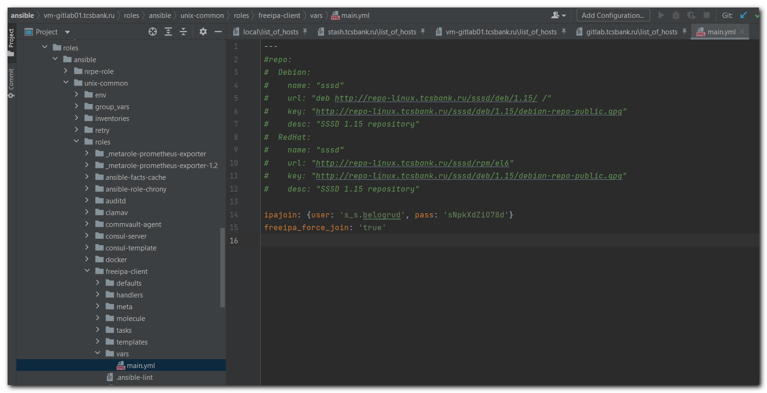
# Copy folder "var" with its file from here.
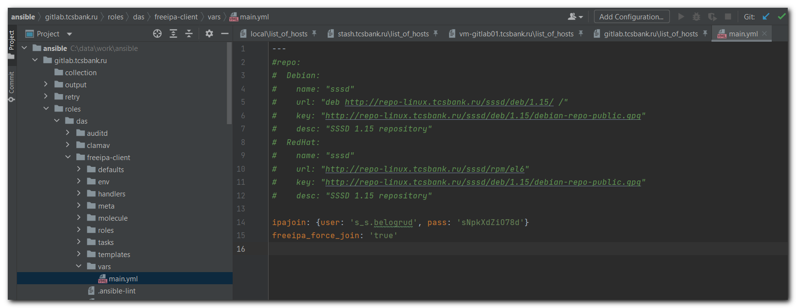

[s.belogrud@nb2339]# cat /drives/c/data/work/ansible/vm-gitlab01.tcsbank.ru/roles/ansible/unix-common/roles/freeipa-client/vars/main.yml
---
#repo:
# Debian:
# name: "sssd"
# url: "deb http://repo-linux.tcsbank.ru/sssd/deb/1.15/ /"
# key: "http://repo-linux.tcsbank.ru/sssd/deb/1.15/debian-repo-public.gpg"
# desc: "SSSD 1.15 repository"
# RedHat:
# name: "sssd"
# url: "http://repo-linux.tcsbank.ru/sssd/rpm/el6"
# key: "http://repo-linux.tcsbank.ru/sssd/deb/1.15/debian-repo-public.gpg"
# desc: "SSSD 1.15 repository"

ipajoin: {user: 's_s.belogrud', pass: '****'}
freeipa_force_join: 'true'
[s.belogrud@nb2339]#

# If you forget make the copy you will get follow shit:
20211220 Переустановка ОС на серверах ml-core (3 шт.) - Ubuntu 18.04

